《程序设计基础》

实验报告

姓名：朱铭宇

学号：2020210574

班级：信息安全01班

学院：计算机与信息学院

2(1)<1>

#include<iostream>

using namespace std;

float num(float x,float a,float b,float c,float d)

{

float sum;

sum = x+(a+b)/(c-d);

return sum;

}

int main(void)

{

float x,a,b,c,d,sum;

cout<<"请输入x，a，b，c，d"<<endl;

cin>>x>>a>>b>>c>>d;

sum = num(x,a,b,c,d);

cout<<sum<<endl;

return 0;

}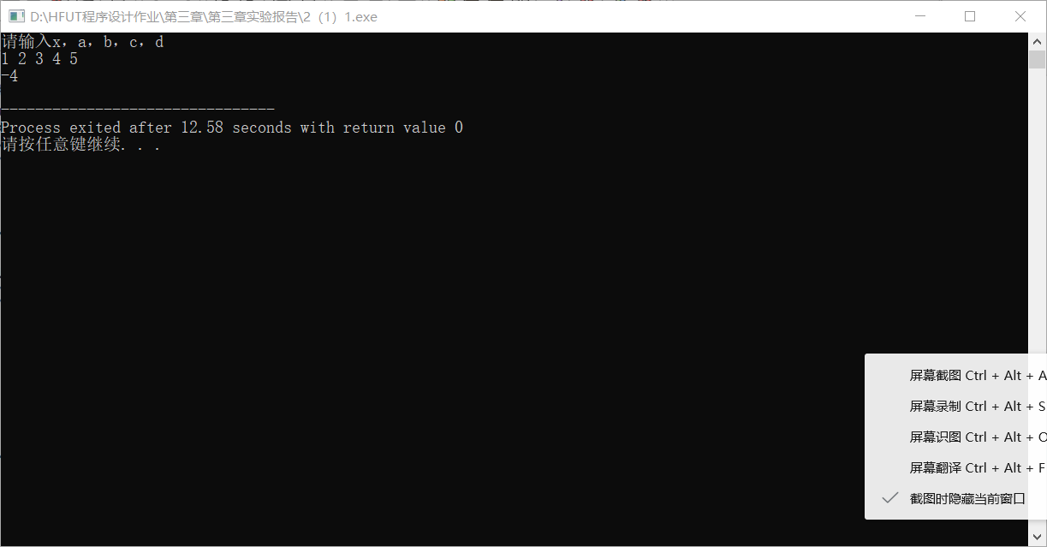

2(1)<2>

#include<iostream>

#include<math.h>

using namespace std;

float num(float x)

{

float m,n,p;

m = 1/(x+1);

n = 1 + 1/(x+m);

p = sqrt(n);

return p;

}

int main(void)

{

float x,sum;

cout<<"请输入一个数"<<endl;

cin>>x;

sum = num(x);

cout<<sum<<endl;

return 0;

}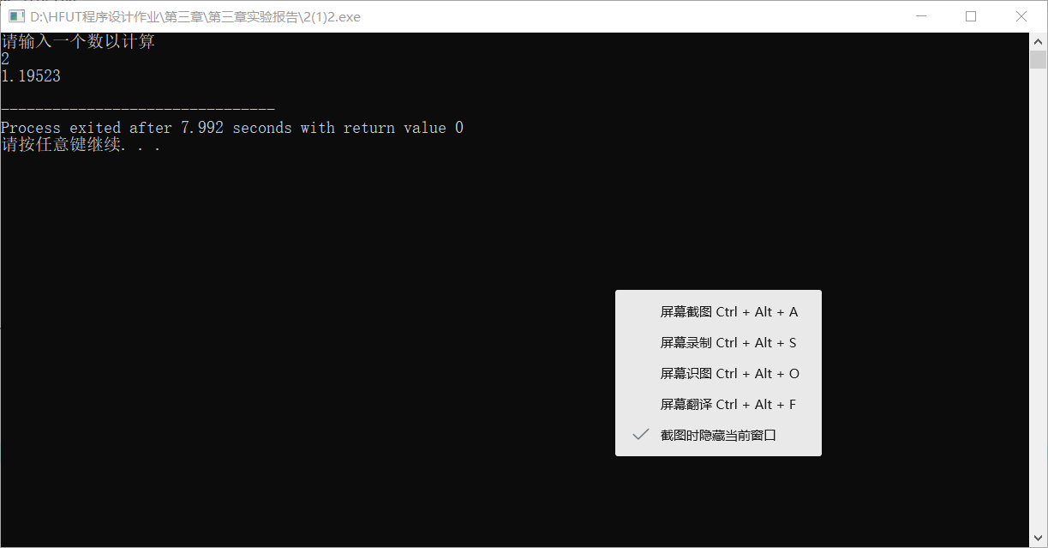

2(1)<3>

#include<iostream>

#include<math.h>

using namespace std;

int main(void)

{

float x,sum;

cout<<"请输入一个数"<<endl;

cin>>x;

sum = sin(x) + cos(x) +atan(x);

cout<<sum<<endl;

return 0;

}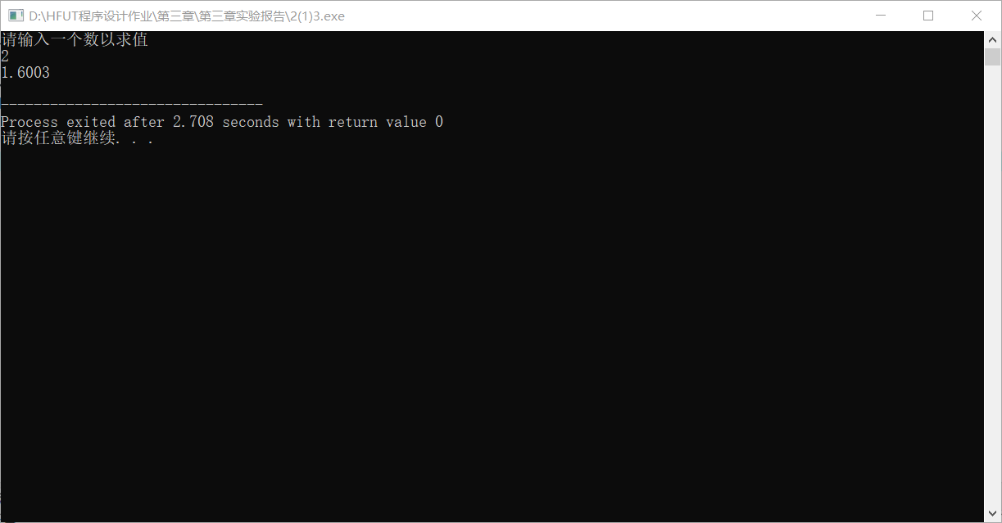

2(1)<4>

#include<iostream>

#include<math.h>

#define e 2.71

using namespace std;

int main(void)

{

float x,y,value;

cout<<"请输入两个数"<<endl;

cin>>x>>y;

value = pow(e,x+y)+pow(e,x-y);

cout<<value<<endl;

return 0;

}

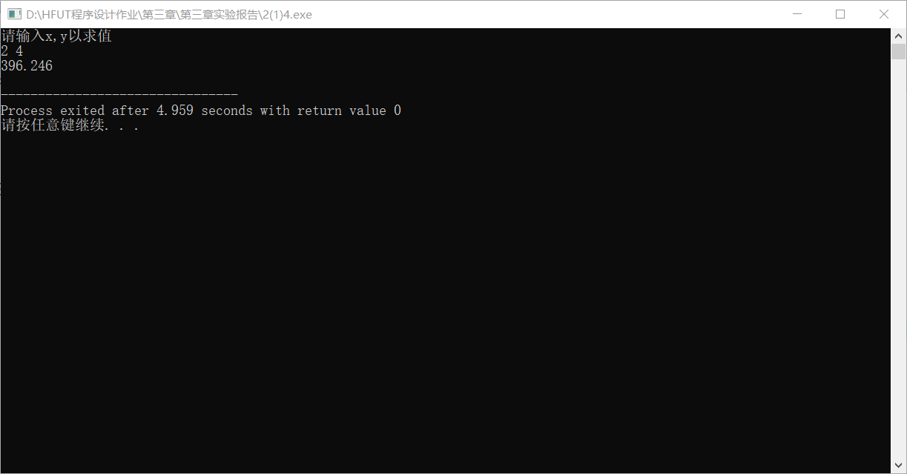

2(1)<5>

#include<iostream>

#include<math.h>

using namespace std;

int main(void)

{

int m, x;

float value;

cout<<"请输入一个数"<<endl;

cin>>x;

m = 1 + sqrt(1 + pow(x,2));

value = log10(m);

cout<<value<<endl;

return 0;

}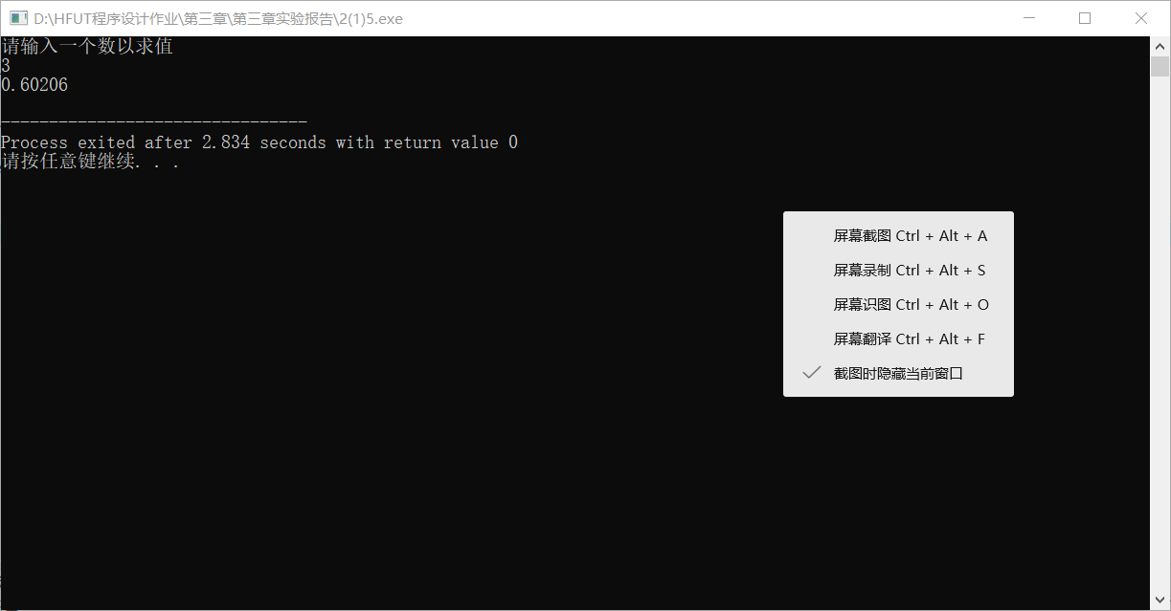

2(1)<6>

#include<iostream>

#include<math.h>

using namespace std;

int main(void)

{

float a,b,value;

cout<<"请输入两个数"<<endl;

cin>>a>>b;

value = fabs(pow(a,2)-pow(b,2))+floor(a-b);

cout<<value<<endl;

return 0;

}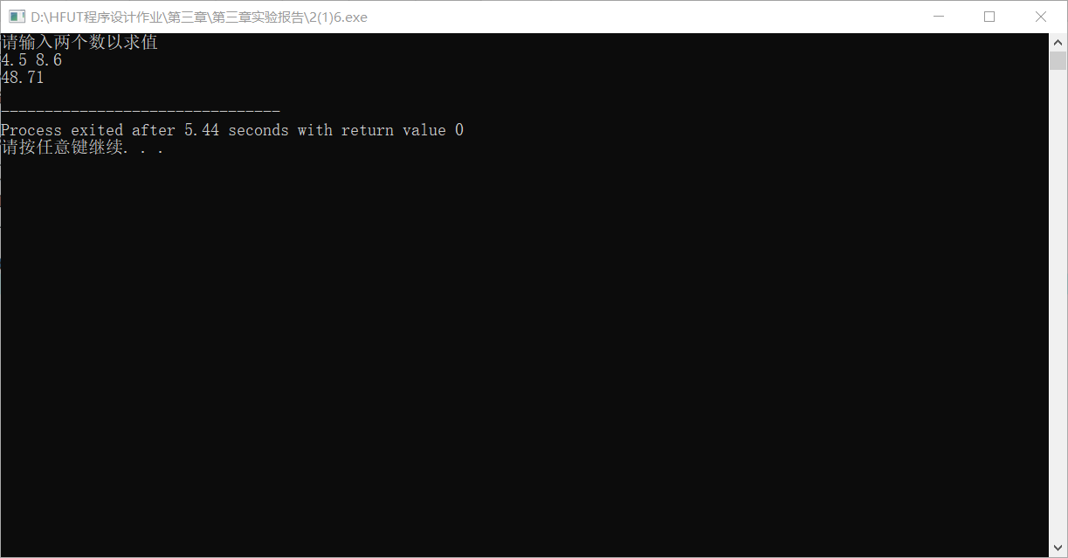

2(2)<1>

#include <iostream>

using namespace std;

int hcf( int u , int v )

{

int a,b,t,r;

if (u > v) {

t = u ;

u = v ;

v = t ;

}

a = u ;

b = v ;

while ( ( r = b % a ) != 0 ){

b = a ;

a = r ;

}

return( a ) ;

}

int lcd( int u , int v , int h )

{

return( u \* v / h ) ;

}

int main(void)

{

int u , v , h , l ;

cin >> u >> v ;

h = hcf ( u , v ) ;

cout << "hcf=" << h << endl ;

l = lcd ( u , v, h ) ;

cout << "lcd=" << l << endl ;

}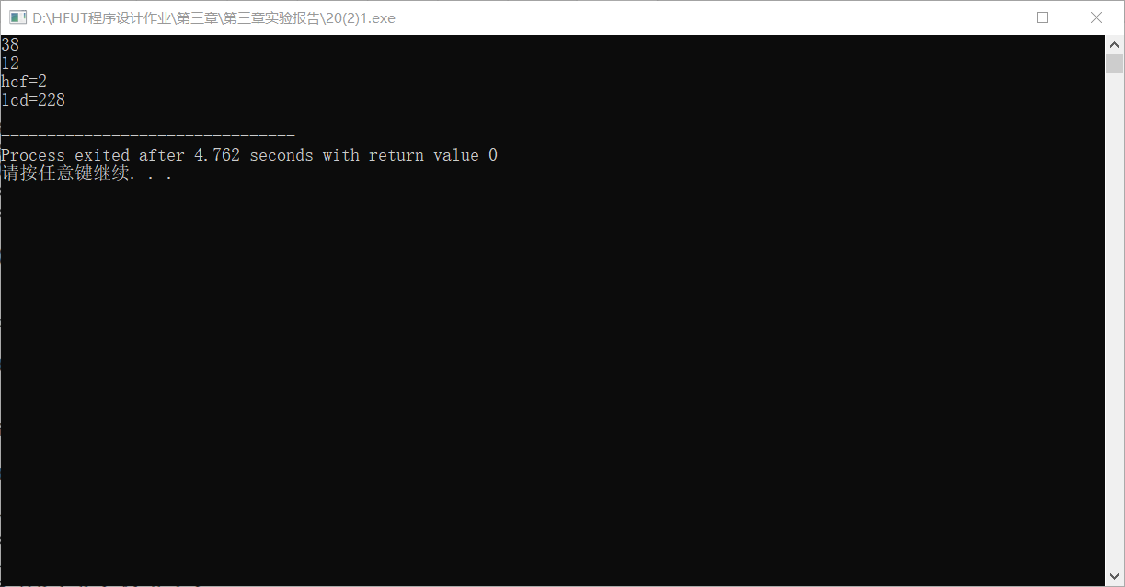

获得两个数的最大公约数和最小公倍数

2(2)<2>

#include <iostream>

using namespace std;

long fib ( int g )

{

switch ( g )

{

case 0 : return 0;

case 1 : return 1;

case 2 : return 1;

}

return ( fib( g - 1 ) + fib( g - 2 ) ) ;

}

int main ( )

{

long k;

k = fib (7);

cout << "k=" << k << endl ;

}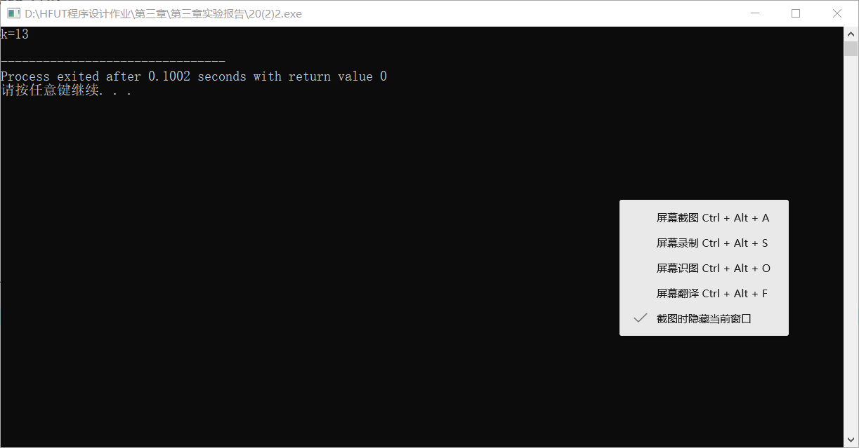

打印第七个斐波那契数

2(3)<1>#include<iostream>

#include<math.h>

using namespace std;

void num(float a, float b, float c)

{

float m,value1,value2;

m = b\*b - 4\*a\*c;

if(m>0)

{

value1 =(-b+sqrt(m))/(2\*a);

value2 =(-b-sqrt(m))/(2\*a);

cout<<"方程的解为"<<value1<<"和"<<value2<<endl;

}

else if(m==0)

{

value1=-b/2\*a;

cout<<"方程的解为"<<value1<<endl;

}

else

cout<<"方程无解"<<endl;

}

int main(void)

{

int a,b,c;

cout<<"请输入三个系数"<<endl;

cin>>a>>b>>c;

num(a,b,c);

return 0;

}